Homework4

Geyunhao 葛云皓（116020910017）

Problem 1

1 Build the Self-organizing feature Map(SOM) with Matlab code,here are the code explain.The stucture is as follows

(1) Competetion Match the best neuron. Calculate the distance between each sample and the initial neural network, from the nearest neuron as the winning neuron

(2) Cooperation：In the process of weight renewal, not only the weight vector of the winning neuron is updated, but also the weight vector of its neighboring neuron is updated according to a "neighbor function"

Give the Initial value of neighbor function and learning rate function. Update the functions after each iteration:

Neighbor_func(t)=neighbor0*exp(-dij/t1); t1=iter/log(neighbor0)

Learn_fun(ct)=learn0*exp(-t/t2); t2=iter

(3) The adjustment of the weight vector occurs within the neighborhood of the winning neuron. At the beginning of the training, this neighborhood is relatively large, and as the training progresses, the neighborhood begins to decrease.And the m nodes of the neuron set within the range and neighborhood, j=1:m；

wj(t+1)=wj(t)+learnfun(t)*neighborfun(t)*(x-wj);

(4)I try different Guassian neighborhood function and learning rate

(5)Get the conresponding data point of each neuron, and store the item of each neuron in the cell’som.mat’

The details is in the code attachment ”SOM.m”

Problem 2

(1) Use the same network to analise the EEG data

(2) Set the neurons map and train the EEG data

(3) Because the scale of Data is so large, set the iteration time 30 times

(4)Get the conresponding data point of each neuron, and store the item of each neuron in the cell’som-EEG.mat’

More details about the code is in the attachment ‘SOM_EEG.m’

Visualisation

(1) Use method of PCA (principle component analiysis)

(2)Use the matlab function to decline the dimention of EEG data and weight matrix of neurons

(3) To fet the figure conveniently , the final dimension of EEG and weight matrix of neurons is 2.

Following are the figure of EEG data and weight of neurons

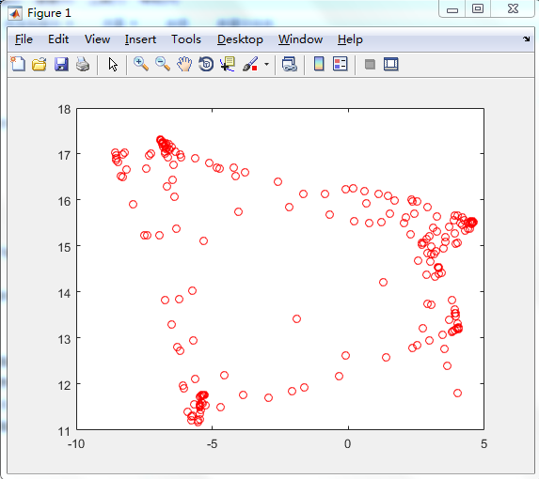

Figure1 Visualisation of EEG data

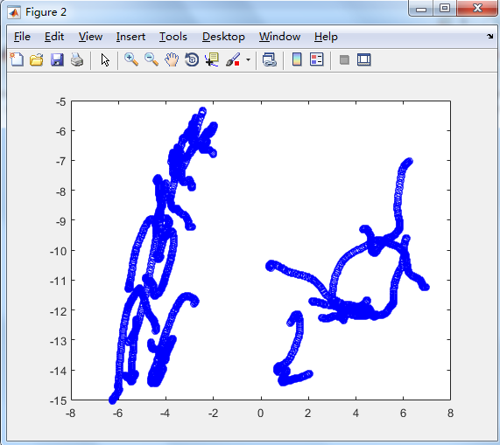

Figure2 Visualisation of weight of neurons

More details are in the ‘visualising.m’